ADVANCED MEDICAL SUPPLY, INC.
3322 N Milwaukee avenue, Chicago, IL 60641
Phone: 773-205-6993 Fax: 773-205-6994
PATIENT NAME: VERNETTA MITCHELL
INSURANCE ID#: 6E28XH2UQ63 DOB: 11/21/1956
ADDRESS: 109 E 43RD ST APT302 CHICAGO, IL 60653
PHONE #: (773) 495-5237
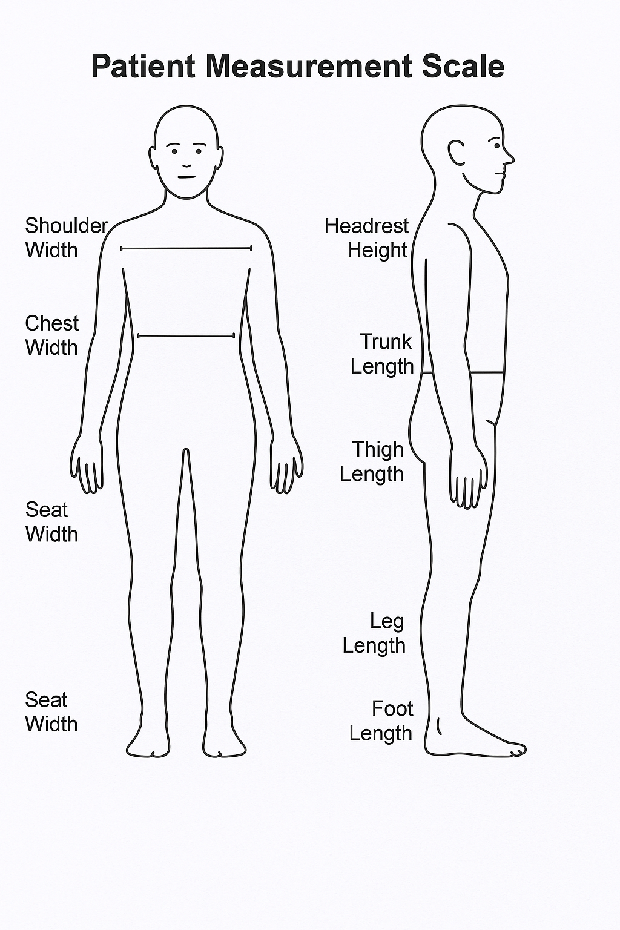  Measurement Area | Value (cm) | Value (in) | Comments
Shoulder Width
Chest Width
Arm Length
Seat Width
Seat Depth
Back Height
Thigh Length
Leg Length
Foot Length
Trunk Length
Headrest Height

Patient’s Signature:___________________________________________________________________ Date:________________
Signature if other than patient:___________________________________________ Relationship:_________________________
Name if other than patient:__________________________________________________________________________________
Reason patient is unable to sign:______________________________________________________________________________
Evaluator’s Signature:_________________________________________________________________ Date:________________
Evaluator’s Name (printed):_________________________________________________________________________________

